

Work proposal for
Synthetic Chemistry Services

Date: 15th June 2022

Presented to:
Brian Hood
Biogen (BIIB)
Brian.Hood@biogen.com

Presented by:
Jayachandran Ezhuthachan
Business Development Manager,
Aurigene Pharmaceutical Services Limited, INDIA
jezhuthachan@aurigeneservices.com

Contents
1. Executive Summary: 3
2. Introduction to Aurigene Pharmaceutical Services Limited 3
2.2 Site of execution 5
3.1. Deliverables: 6
4. Case studies on our experience in organic synthesis of drug like molecules 6
5. Key Project Assumptions: 7
7. Business continuity Plan (BCP) COVID-19 outbreak 9
7.1. BCP Strategy: 10
7.2. BCP in place: 11
7.2.1. Operational aspects 11
7.2.2. Resource plan 11
7.2.3. Communication plan 11
8. Communication & Governance 12
8.1. Communication 12
8.2. Governance: 12
9. Documentation 12
10. Intellectual Property 12
11. Other 12
12. Validity 13
13. Authorization 13
14. Anexure-1 14
15. Anexure-2 15

Executive Summary:
This proposal is submitted by Aurigene Pharmaceutical Service Limited (“APSL”) to Biogen (BBIB), a US incorporated global leader in the discovery, development, manufacturing, and commercialization of innovative therapies, for synthetic chemistry services as suggested in the RFP document.

APSL has the capability, capacity and experience to deliver projects in all type of services as described in Biogen’s RFP. Our response is designed to reflect our teams’ chemistry capabilities, experience and strength in meeting the proposed deliverables with high quality and fast turnaround time.

As suggested by Biogen in the RFP, this proposal includes
- Introduction to APSL
  - Organization team
  - Site of execution
- Case studies on our experience in organic synthesis of drug like molecules. The case studies will explain the scientific approach focusing on route identification, execution plan and project timelines. The type of case studies discussed will be as suggested by Biogen that will involve Straightforward (<5 linear steps), Challenging (route development required, multiple routes attempted, timelines, > 5 linear steps) and One scaled up reaction.
- Summary of FTE pricing model for the synthetic chemistry services
- Key assumptions
- COVID business continuity operations

We are governed by a strong corporate framework, customer centric systems and processes which meet global standards of safety, quality, and data integrity. APSL does not carry out any in-house drug discovery projects and has robust mechanism in place to guard customer confidentiality.

We thank Biogen for their time and consideration and look forward to further discussions on our proposal.

Introduction to Aurigene Pharmaceutical Services Limited
APSL is a leading contract research, development and manufacturing organization (CDMO) providing end-to-end solutions. With a strong legacy we are ideally positioned to serve global pharma and specialty companies worldwide.
Our end-to-end integrated services offerings range from chemistry, biology, custom development and manufacturing of clinical compounds to enabling IND/NDA fillings and commercial contract manufacturing. Our discovery services are offered from our world-class R&D centres situated at Bangalore and Hyderabad in India. The discovery services are spearheaded by ~450 scientists working across the drug discovery value chain with more than 50 of them having Ph.D.'s with post-doctoral experience from western research labs. Our development capabilities are supported by multiple scale-up and commercial manufacturing facilities in India, UK, Mexico and the United States.
Our endeavour is to help accelerate the journey from laboratory to market by providing access to our capabilities, knowledge and experience. APSL is committed to continuous investment in acquiring world class talent and innovative technologies, vis-a-vis expansion of capacity in all areas of service.
While accelerating the R&D programs of our clients, we keep sustainability, quality, environment, health and safety (EHS) at the forefront of everything we do.

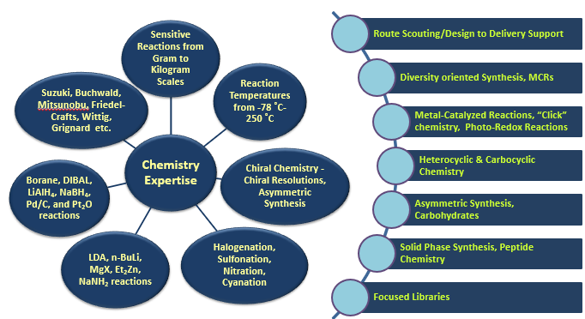

APSL is rapidly positioning itself to be a leading provider of solutions to synthetic organic chemistry ranging from traditional heterocyclic chemistry, library synthesis, phosporamidite chemistry, photoredox reactions and more.

2.1 Organization structure
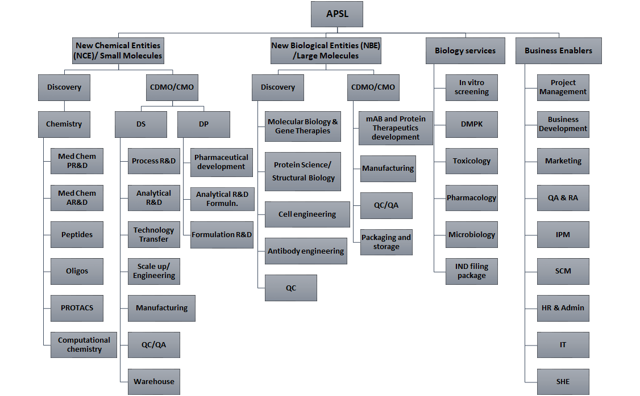

The services quoted in this proposal will be executed by the New Chemical Entities (NCE) team at APSL.

2.2 Site of execution
The proposed project services in the proposal will be executed from our state-of-the-art facility located in Hyderabad/ Bangalore, India.
The scientific team that will be involved in the project comprises of scientific experts having experience in diverse fields of small molecule discovery. The scientists have post docs from western universities and industrial experiences in relevant area of research. We have scientists with mixed experience and expertise who are masters graduates with 5-15 years of experiences; PhDs with 5-10 years of industrial experience in the relevant field and Post docs with 5-10 years of industrial experience in the relevant field. We maintain a PhD to Masters ratio of 1:6.
The list of instruments available at site of execution to support the relevant services in this project is shared under Annexure-1 in this proposal.

- Scope of services
Below are the chemistry activities that will be offered under non-GMP conditions as suggested in the RFP
- Synthetic chemistry services
- Route scouting and development
- Library synthesis
- Access to FFS synthesis
- Building block synthesis/acquisition
- Scale up synthesis and purification up to 500 gram scale
- non-enzymatic catalysis reaction screening
- Chiral separation services
- Compound management services

Deliverables:
- 5 mg – 20 mg of final compound
- >90% purity determined by NMR and LCMS
- Chiral purity as required

Case studies on our experience in organic synthesis of drug like molecules
Case Study – 1
The originally proposed route from collaborator had three major bottlenecks – Lack of availability of RM-2 with a specific nitro group in place, low yield for cyclization of the amine 3 to intermediate 5, and C-C bond formation reaction of intermediate 6 was not amenable using Suzuki, Stille or Molander couplings. These issues were resolved by developing a regioselective nitration on the acid itself instead of the ester, carrying out a neat cyclization with urea at 180 °C and finally optimizing the C-C bond formation under Fe(acac)-mediated Kumada coupling reaction to successfully generate the scaffold 9, which was later used for the synthesis of a number of NCEs through amidations and reductive aminations.

Case Study – 2
The originally proposed route from collaborator had multiple bottlenecks – amination on the bromo-amino-triazole has failed under S_{N}Ar- or Pd- or Cu-mediated coupling conditions. Introduction of the piperazine core for derivatizations was originally planned through the C-6 bromination followed by S_{N}Ar- or Pd-mediated coupling conditions, though the regioselective halogenation has failed (-Br reacting on the C-5 alkyl substituent), making this route inaccessible. These issues were circumvented by pre-installation of the amine at C-2 position by a high-yielding condensation reaction, followed by cyclization with a beta-keto ester where piperazine was pre-linked, to access the desired fused heterocyclic system in good yield and purity. This strategy was later used for the synthesis of >80 NCEs, varying the substituents at C-2, C-5 and C-6 positions and their corresponding functionalization.

Key Project Assumptions:
- Information sharing: APSL expects to establish an effective mechanism of information sharing between customer and itself which will include, when applicable, knowledge on prior art, technologies, processes, and analysis methods.
- Procurement: APSL will identify and acquire all goods, services and/or works from external sources ensuring quality, quantity, turn-around time. Vendor qualification, raw material and consumables testing is not considered in this proposal. All raw material and consumables will be released based on Certificate of Analysis (CoA) from the supplier.
- Documentation: APSL will generate all the documentation required to execute the project as per internal guidelines such as but not limited to Standard Operating Procedures, Batch Production Records, Development Protocols, CoA and records, etc.
- Quality Control and Assurance: All activities in this proposal are non-GMP.
- Outsourcing: APSL will engage appropriate third-party (ies) for specifically selected activities, tests and analyses currently not available in APSL, upon client’s consent (e.g. large scale chiral purification, HRMS, trace metal analysis, XRD services, etc).
- Licensing & IP: Any licensing and IP requirements with third party suppliers of technology and material will be provided by customer.
- Business Proposal
  - FTE Pricing model
In this section, APSL proposes an FTE arrangement with flexibility in deploying FTEs as per the needs of the project. Based on the progress and requirement in the project, Biogen will have an option to extend the period of collaboration or increase/ decrease the number of FTEs as desired, with at least 30 days advance notice to APSL.
- FTEs will be charged at annual rate as per the table below
Business Mode | FTEs Range | FTE price/ annum (USD)
FTE | 0 to 25 FTEs | 65,000
FTE | 26 to 50 FTEs | 62,000
FTE | 51- 75 FTEs | 60,000

- Details on FTE pricing discount can be discussed mutually and agreed based on the volume of FTEs and the period of time committed by Biogen.

- Deployment of additional FTEs apart from originally agreed FTEs will be allotted upon mutual agreement between both Biogen and APSL, based on the project requirement and progress in each phase of the program and upon a formal approval from Biogen.

- All FTE teams will be led by a technical project leader with relevant industrial R&D experience, excellent in English communication, strong scientific skills and troubleshooting capability.

- Additionally, APSL will deploy a non-billable project manager to co-ordinate operational aspects of the project.

- APSL will also be responsible for providing sufficient other personnel as necessary to perform all administrative and other non-scientific activities to support the services.

  - Terms and conditions: FTE Model
    - FTE Price Validity and Invoicing
- The pricing is valid for period of 03 years from the start date as suggested by Biogen.
- FTE billing will be done, for the actual number of FTEs agreed between Biogen and APSL during the said period, on a monthly basis.
- Reagent procurement phases will have no FTE billing

    - Consumables cost:
- FTE Pricing include cost of standard reagents, chemicals and consumables for chemistry services, captured in Annexure 2.
- FTE Pricing does not include cost of project specific reagents, chemicals, speciality consumables, speciality solvents for chemistry services. APSL will share the list of all raw materials and consumables for Biogen Pharma’ s confirmation ahead of raising the invoice.
- The invoice for all consumables will be raised at the end of each month and same shall be paid by Biogen Pharma on a monthly basis.
    - Chiral separation
- The FTE cost is inclusive of chiral separation up to 25 mg scale of final output /product and will not be billed to Biogen Pharma.
- In case Biogen Pharma desires to synthesize >25 mg final output, APSL shall submit a separate quote for synthesis and it will be taken up on a Fee-For-Service basis. For example, if Biogen Pharma desires a chirally separated, final compound of 50 mg, in such instance APSL will provide a separate quote for this activity. However, if Biogen Pharma desires to have a chirally separated, final compound of 20 mg, this will be covered in the FTE cost provided in the Pricing summary table.
- Any outsourced study cost will be borne by Biogen Pharma at actuals.

    - Shipping costs:
- FTE pricing includes cost of once-a-week normal shipment to Biogen Pharma. Cost of dry ice shipment is not included in the above pricing. Any additional shipments in a week and dry ice shipments will be billed to Biogen Pharma at actuals.
- Shipping of all samples will be done by certified express carriers in accordance with DAP Incoterm 2010, APSL will ensure all essential documentation for the shipment
- Duty & clearance charges for chemicals/ test items shipped by the Biogen to APSL specific to project, if any, will be charged as pass through costs at actuals to Biogen.

Business continuity Plan (BCP) COVID-19 outbreak
At APSL, implementation of Business Continuity Plan (BCP) has helped to protect employees and contractors right from the start of COVID-19 across all sites. This has also helped to satisfy the needs of patients across the globe by continuing supply of medicines in line with commitment of our services during pandemic times. Business Continuity Plan (BCP) is reviewed and upgraded with the global, national, and local situations as well as guidelines issued by the national / international expert agencies on COVID-19 from time to time.
Currently APSL is working with 100 % capacity onsite as per our updated BCP guidelines through continuous focus on strengthening processes, system & personal behaviors and this occupancy will be followed and will and remain in action, when active COVID cases at respective sites are less than 10.
Our key measures to monitor and control the COVID cases at site, to be below 10 are
- Self-declaration & Thermal screening will be made mandatory for all entering the site from onset to offset of the peak.
- Employees with comorbidities will be allowed to work from their respective site provided they are fully vaccinated and not suffering from any active illness because of their comorbidities.
- Employee with Critical illness must provide medical fitness certificate from treating physician/undergo evaluation at OHC for fitness to Work irrespective of vaccination status.
- Pregnant & nursing women can work from site subject to submitting declaration to the HR prior to joining provided they are fully vaccinated.
- All meetings will be carried out virtually as far as possible from onset to offset of the peak. For physical meetings, strict SMS compliance to be maintained and wherever the social distance is a challenge, usage of N95 mask is recommended.
- All company buses transport with 100% occupancy with strict SMS compliance & all Buses need to be thoroughly sanitized once a day.
- Effective Sanitization and Social distancing measures
  - Zone based operating plan (as needed)
  - Cafeteria: With modified table and chair arrangement
  - Lab operation: With social distancing measures and face shields (as needed)
- Crèche, Gym, recreational areas remain closed & gatherings /conferences will be suspended within the campus from onset to offset of the peak.
- Domestic travellers -Fully vaccinated Domestic Travelers are allowed to enter the campus, but post travel need to undergo OHC screening for 3 days.

BCP Strategy:
Apart from Covid-19 outbreak, Business continuity Plan operations are part of our regular organizational process as a part of operational excellence.
The strategy leverages the following:
  - Incident response: Emergency response teams per locations to respond to an emergency e.g. Accidents, fire and other calamities [natural or man-made]
  - Critical enterprise assets: Discover, map and apply governance to key assets
  - Cyber and information security: Respond and recover from attacks
  - Crisis management: Orchestrate response plans, achieve a 360-degree of the current crisis status view with specific continuity plan in place to respond on current pandemic. Crisis management communication plan.
  - Disaster recovery: Minimize the impacts, structure and recovery
  - Manage Quality, Environmental, Health and Safety risks
  - Supply-chain management: On going supplier assessments and alternate vendor development program for supply continuity of key materials.
  - Continuity management: Analyze business impact and set return-to-work tactics
  - Risk management: Identify and assess business risks on an ongoing basis, monitor and minimize issues
  - Governance, audit and compliance: Continuously monitor compliance, apply industry guidelines, robust internal audit program
  - Service operations: Assure operational excellence and efficiency, adopting digital and analytics-driven monitoring

BCP in place:
Top priorities
- Our partner’s business continuity
- Our commitment to advance pharmaceutical research and bring new medicines to market
- Employees’ safety, health and wellbeing

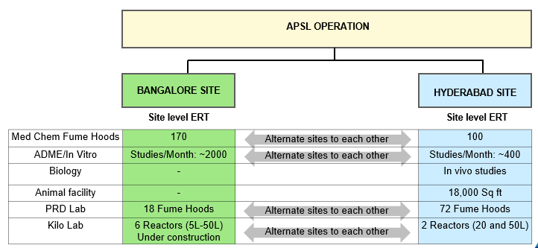
Operational aspects

Resource plan
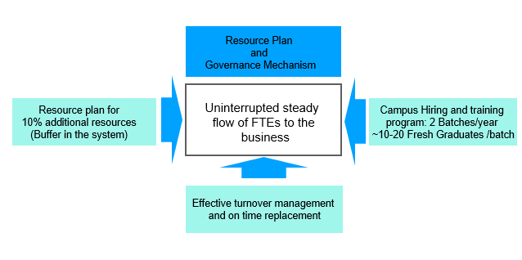

Communication plan
- In the event of an emergency/Business Continuity event, CEO conducts daily meetings
- Site leaders (Bangalore and Hyderabad) conduct team meetings of the respective sites, daily
- Communication is cascaded to teams through team meetings as well as common communications
- Communication (internal/external) is considered as one of the key activities during BCP
- BCP meetings and communication continue until business as usual is established

Communication & Governance

Communication
We propose 3 layers of communication between APSL and Biogen
  - Project level - Weekly
  - Functional Head level - Monthly
  - Senior leadership – Quarterly

Governance:
- APSL and Biogen shall together constitute a Steering Committee that will agree on the criteria for each stage of the program.
- The committee will also oversee the progress of the project conducted under the agreement.

Documentation
Experimental information will be entered into the notebooks in full accordance with the Biogen notebook policy and SOP or as mutually agreed between Biogen and APSL.
Biogen will provide APSL the SOP ‘Instructions for use of laboratory notebooks’ and APSL guarantees that all involved FTEs observe the guidelines of the SOP.

Intellectual Property
APSL will ensure that Intellectual Property generated during the term of this project shall be transferred to Biogen. Biogen will exclusively own all data generated for the project (s).

Other
Biogen may terminate the project with a notice period of thirty (30) days in case Biogen considers that the project within which Biogen entrusted APSL with the performance of the services is not of interest any more for any reasons or that following preliminary results obtained during the performance of the services holds no longer any interest to have the services performed by APSL.

In case of termination for any cause whatsoever, APSL shall (i) return to Biogen all data, documents and remaining quantities of materials, samples, and product supplied, (ii) provide Biogen with a report concerning the services as well as the results already obtained at the effective date of termination. Biogen shall pay to APSL the sums due in consideration of the services actually performed and for reimbursable expenses reasonably incurred up to the effective date of termination, including unavoidable costs for product-specific reagents already ordered or otherwise resources committed at the time of termination.

Validity
This proposal is valid for 190 days from the date of submission. Should there be any questions or clarifications needed, please feel free to contact Jayachandran Ezhuthachan.

Authorization
If you accept this quotation, please sign and return this document via email. Your signature further constitutes acceptance of the price, schedules, payment terms and other terms and conditions set out or referred to in this quotation.

Biogen (BBIB) | Aurigene Pharmaceutical Services Ltd.
By _____________________________ | By _____________________________
Name _____________________________ | Name _____________________________
Title _____________________________ | Title _____________________________
Date _____________________________ | Date _____________________________

Annexure-1
List of instruments available for synthetic chemistry services at APSL is shown below
Instruments | Manufacturer | Number of units
Peptide synthesizer | Liberty Blue with HT 12 | 1
Microwave | Anton Parr / 400 or 450 | 3
Combi flash | Telydayne/RF200 or RF300 | 20
Lyophilizer | Martin Christ/ Buchii | 4
Purification:
SFC hybrid 10-20 | PIC | 1
Agilent 1200 and 1260 Infinity | Agilent | 13
Shimadzu LC 8A | Shimadzu | 1
MADP LC2020 | Shimadzu | 2
NMR:
Varian 300 MHz | Varian | 1
Varian 400 MHz | Varian | 1
Jeol 400 MHz | Jeol | 1
Bruker 400 MHz Auto sampler | Bruker | 1
LCMS:
API 3200 | AB Sciex | 1
Nexara UFLC LCMS2020 | Shimadzu | 4
Agilent Infinity LC/MSD | Agilent | 3
HPLC:
Waters ARC/ Alliance | Waters | 12
Shimadzu SIL 20 | Shimadzu | 2
Agilent 1200 and 1260 | Agilent | 3
Other instruments:
KF Titrator | Metrohm | 1
SOR Autopol automatic Polarimeter | Rudolph | 1
IR Spirit | Shimadzu | 1

Annexure-2
Standard Laboratory Chemicals
General Inorganics | Specification | CAS No
Alumina, Neutral | Aluminium oxide 90, 70-230 mesh ASTM | 1344-28-1
Ammonia solution, 25% | 28.0-30.0% as NH3 | 7664-41-7
Ammonium chloride | ≥99.5% | 12125-02-9
ammonium hydroxide |  | 1336-21-6
Anti-bumping granules
Calcium chloride | technical grade, −4-+30 mesh | 10043-52-4
Celite 545 |  | 61790-53-2
Activated Charcoal | decolorizing agent | 7440-44-0
Citric acid | ≥99% | 77-92-9 99
Cuprous chloride | 97% | 7758-89-6
Drierite, 8 mesh, no indicator | without indicator, 8 mesh | 7778-18-9
hydrobromic acid |  | 10035-10-6
Hydrochloric acid (sg 1.18) | 37% | 7647-01-0
lithium hydroxide | ≥98% | 1310-66-3
Magnesium sulfate | anhydrous, reagent grade, ≥97% | 7487-88-9
molecular sieves |  | 70955-01-0
Ninhydrin spray |  | 485-47-2
Nitric acid | 70% | 7697-37-2
Phosphomolybdic acid | 95% | 51429-74-4
phosphoric acid |  | 7664-38-2
Phosphorus pentoxide | ≥98.0%, powder | 1314-56-3
potassium acetate |  | 127-08-2
potassium bicarbonate |  | 298-14-6
Potassium carbonate | 99% | 584-08-7 99
Potassium fluoride | ≥99.0% | 7789-23-3
Potassium hydroxide | ≥90%, flakes | 1310-58-3
potassium phosphate tribasic |  | 7778-53-2
potassium phosphate dibasic |  | 04/11/7758
potassium phosphate monobasic |  | 7778-77-0
Sand | −50-70 mesh particle size | 14808-60-7
Sieves, 3 angstrom | pellets, 1.6 mm | 308080-99-1
Sieves, 4 angstrom powder | powder, activated, 5 μm | 70955-01-0
Sieves, 4 angstrom | pellets, 1.6 mm | 70955-01-0
Silica gel with moisture indicator (blue gel), desiccant ~1-3mm |  | 112926-00-8
Silicone oil, high temp. (230 C) | Silicone oil, high temp. (230 C) | 63148-62-9
sodium acetate |  | 127-09-3
Sodium bicarbonate | ≥99.5%, crystalline | 144-55-8
Sodium carbonate | ≥99.0% | 497-19-8
Sodium chloride (AnalaR) | ≥98%, 80 mesh particle size | 7647-14-5
Sodium hydride, 60% in oil | 60 % dispersion in mineral oil | 7646-69-7
Sodium hydroxide | 97%, beads | 1310-73-2
Sodium sulfate | ≥99.0%, anhydrous, granular | 7757-82-6
sodium sulfite |  | 7757-83-7
Sodium thiosulphate.5H2O | Pentahydrate, 99.5% | 10102-17-7
Sodium iodide | ≥99% | 7681-82-5
solka floc
Sulfuric acid | 95-98% | 7664-93-9
Acetic acid | glacial, 99.8% | 64-19-7
Acetone | ≥99% | 67-64-1
Acetonitrile (LC/MS) | LC-MS grade, ≥99.9% | 75-05-8
Acetonitrile | 99% | 75-05-8
Chloroform | ≥99% | 67-66-3
cyclohexane |  | 110-82-7
1,2-dichloroethane | ≥99.0% | 107-06-2
Dichloromethane | Anhydrous, ≥99.5% | 75-09-2
Dichloromethane | ≥99.5%, | 75-09-2
Diethyl ether, AR | ≥99.0% | 60-29-7
Diethyl ether | anhydrous, ≥99.7%, | 60-29-7
Diisopropyl ether |  | 108-20-3
N',N-dimethylacetamide |  | 127-19-5
N,N-Dimethylformamide | anhydrous, 99.8% | 68-12-2
N,N-Dimethylformamide | ≥99.8% | 68-12-2
Dimethylsulfoxide | ≥99.9% | 67-68-5
Dimethylsulfoxide | Anhydrous, ≥99.9% | 67-68-5
1,4-dioxane | ≥99.0% | 123-91-1
Ethanol | anhydrous, ≥99.5% (200 proof) | 64-17-5
Ethanol | reagent grade, denatured | 64-17-5
Ethyl acetate | ≥99.5%, | 141-78-6
n-Heptane | 99% | 142-82-5
hexanes |  | 110-54-3
Methylcyclopentane |  | 96-37-7
3-Methylpentane |  | 96-14-0
2-Methylpentane |  | 107-83-5
isopropyl acetate |  | 108-21-4
Methanol | Anhydrous, ≥99.8% | 67-56-1
Methanol | ≥99.5%, | 67-56-1
Methanol (for LCMS) | LC-MS grade, 99.9% | 67-56-1
Methyl tert-butyl ether |  | 1634-04-4
2-propanol | ≥99% | 67-63-5
Tetrahydrofuran | ≥99.9%, inhibitor-free, anhydrous | 109-99-9
Tetrahydrofuran | ≥99.0%, Inhibitor-free | 109-99-9
Toluene | ≥99.5% | 108-88-3
Anisole | 99% | 100-66-3
1,2-dimethoxyethane | anhydrous, 99.7% | 110-71-4
Triethylamine | ≥99% | 121-44-8
pyridine | ≥99% | 110-86-1

